Steps for Converting from Word to HTML
One Suggested Method

- Open the file in Microsoft Word.
  - Add accessibility features.
  - After adding accessibility features, copy the text.
- Use the HTML-Cleaner to remove Word code.
  - Go to the “HTML-Cleaner. (new window).” Be patient, it takes a while to load.
  - Paste the text that you copied from Word into the left window (the source window).
  - Click the Clean HTML button at the lower right side immediately below the HTML window.
Select and copy all of the text in the Source window: Ctrl + A to select all; Ctrl + V to copy.
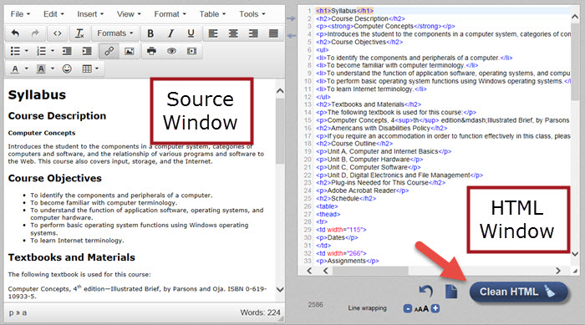
- Go to Desire2Learn to paste the text.
  - Logon to D2L and select a course where you wish to paste the content.
  - Click on Content. If needed, create a module; otherwise, click on a module title.
  - Click the New button and choose Create a File.
  - Click on “Enter a title” and type a name.
  - Click on “Select a Document Template” and click on “Browse for a Template.” Choose “Shared Files” at the left then click on the “Styles” folder at the right. Choose the “D2LBasic” folder or the “D2LSimple” folder or select a style from your Course Files.
  - Click on Add. You will see a blank screen.
  - Click inside the editing window and paste the text you copied from the HTML-Cleaner.
  - Edit the Content as needed.
  - Click on Publish.

Optional
If you wish to remove extra spacing from the table, follow these steps:
- From the D2L editing window, select and copy the table.
- Go to the HTML-Cleaner and paste it to the source window.
- Below the HTML window, enter <p> in the “Find” textbox. Click the plus button to add another box and enter </p> in the “Find” box. Leave the “Replace with” boxes blank.
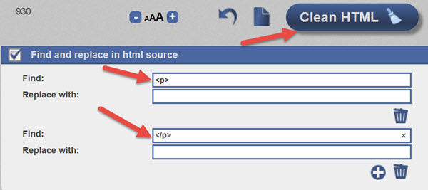
- Click the “Clean HTML.”
- Select the table from the Source window and copy the text. Go to D2L and paste the table at the desired location in the HTML editor.
- Publish.

